University Of Azad Jammu AND Kashmir,Muzaffarabad



Student Name: Marium Shaheen
Class RollNo: 2024-SE-30
Course: Database Systems
Submitted to: Engr.Awais Rathore

Department Of Software Engineering

Open ended lab
Car Rental Management System

Objective
The objective of this lab is to design and implement a database for a Car Rental Management System. The system is designed to manage customer information, vehicle information, rental records, returns, and payments.
The lab also focuses on database normalization from 1NF to 3NF, SQL JOIN operations, views, triggers, stored procedures, and database optimization.

Problem Description
Car Go Rentals is a local car rental company that currently manages its customer, vehicle, rental, return, and payment information using spreadsheets.
Managing the information in spreadsheets can result in:
• Duplicate records
• Inconsistent information
• Difficulty in maintaining rental records
• Difficulty in generating reports
• Problems in tracking vehicle availability
• Difficulty in maintaining customer rental history
A database management system is therefore required to organize the information properly.

The proposed system maintains:
Customer information
Vehicle information
Rental records
Return information
Payment information
Vehicle availability
Customer rental history
Vehicle activity
The system also ensures that a vehicle which is already rented cannot be assigned to another active rental.

Database Design
The database was designed using four main tables:
1. Customers
2. Vehicles
3. Rentals
4. Payments
Each table stores information related to a specific part of the car rental system.
CREATE DATABASE CarRentalDB;
USE CarRentalDB;

-- Customers Table
CREATE TABLE Customers (
CustomerID INT PRIMARY KEY AUTO_INCREMENT,
Name VARCHAR(100) NOT NULL,
Phone VARCHAR(20) UNIQUE NOT NULL,
Email VARCHAR(100) UNIQUE
);

-- Vehicles Table
CREATE TABLE Vehicles (
VehicleID INT PRIMARY KEY AUTO_INCREMENT,
VehicleNumber VARCHAR(20) UNIQUE NOT NULL,
Model VARCHAR(50) NOT NULL,
DailyRate DECIMAL(10,2) NOT NULL CHECK (DailyRate > 0),
Status VARCHAR(20) DEFAULT 'Available'
);

-- Rentals Table
CREATE TABLE Rentals (
RentalID INT PRIMARY KEY AUTO_INCREMENT,
CustomerID INT,
VehicleID INT,
RentalDate DATE NOT NULL,
ReturnDate DATE,
FOREIGN KEY (CustomerID) REFERENCES Customers(CustomerID),
FOREIGN KEY (VehicleID) REFERENCES Vehicles(VehicleID)
);

-- Payments Table
CREATE TABLE Payments (
PaymentID INT PRIMARY KEY AUTO_INCREMENT,
RentalID INT,
Amount DECIMAL(10,2) NOT NULL,
PaymentDate DATE NOT NULL,
FOREIGN KEY (RentalID) REFERENCES Rentals(RentalID)
);

Normalization
Normalization is the process of organizing data into properly structured tables.
The purpose of normalization is to:
• Reduce data redundancy
• Avoid duplicate information
• Improve data consistency
• Prevent insertion anomalies
• Prevent update anomalies
• Prevent deletion anomalies
• Make database maintenance easier
The original rental information was represented using a single structure containing customer, vehicle, rental, and payment information.
The normalization process was performed from 1NF to 3NF.

First Normal Form (1NF)
A relation is in First Normal Form when:
• Each column contains atomic values.
• There are no repeating groups.
• Each record can be uniquely identified.
• Each record can be uniquely identified.
The original table already contains single values in each field, so we can make the structure 1NF by ensuring every rental is represented as one record.
1NF Table
Rental 1NF

Partial Dependencies in the Original Structure
The original structure can contain dependencies where some information depends only on a part of the identifying information rather than the complete rental record.
For example:
Customer information depends on CustomerID.
Vehicle information depends on VehicleID.
Rental information depends on RentalID.
Keeping all these details in one table causes unnecessary repetition.
Result of 1NF
The data is made atomic and repeating information is removed, but redundancy can still exist.

Second Normal Form (2NF)
A relation is in Second Normal Form when:
1. It is already in 1NF.
2. There are no partial dependencies.

Third Normal Form (3NF)
A relation is in Third Normal Form when:
1. It is already in 2NF.
2. There are no transitive dependencies.
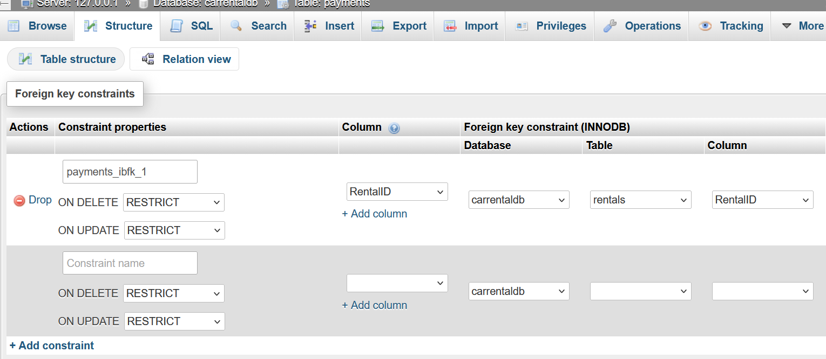
In the final database design, customer details are stored in the Customers table, vehicle details are stored in the Vehicles table, rental information is stored in Rentals, and payment information is stored in Payments.
Result of 3NF
The final design contains four properly separated tables:
• Customers
• Vehicles
• Rentals
• Payments
This structure reduces redundancy and improves data consistency.

Functional Dependencies
The important functional dependencies in the final design are:
Customers
CustomerID determines the customer information.
CustomerID → CustomerName, CustomerPhone, CustomerEmail, DrivingLicense
Vehicles
VehicleID determines the vehicle information.
VehicleID → VehicleNumber, VehicleModel, VehicleType, DailyRate, VehicleStatus
Rentals
RentalID determines the rental information.
RentalID → CustomerID, VehicleID, RentalDate, ExpectedReturnDate, ActualReturnDate, RentalCharge, RentalStatus
Payments
PaymentID determines the payment information.
PaymentID → RentalID, PaymentDate, PaymentAmount, PaymentMethod
These dependencies demonstrate that the database structure follows the principles of normalization.

JOIN Queries
JOIN operations are used to retrieve related information from multiple tables.
Four JOIN queries were implemented according to the lab requirements.
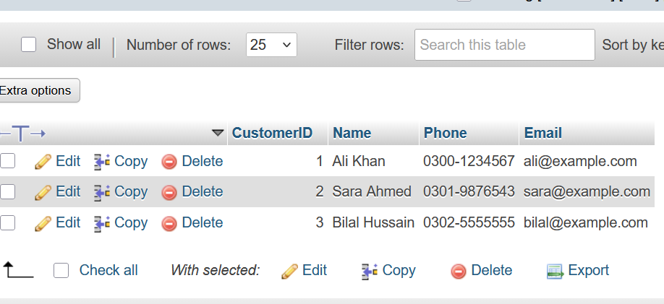
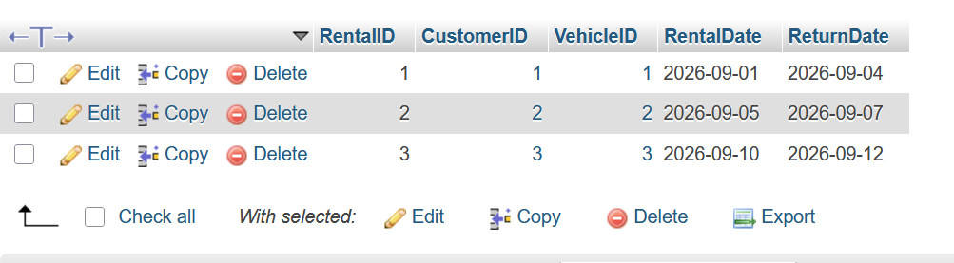

1 — Display Rental Information
The Customers, Rentals, and Vehicles tables are joined using their related keys.
This query provides a complete view of each rental.

2 — All Customers and Their Rentals
The second query displays all customers and the vehicles they have rented.
A LEFT JOIN is used so that customers who have never rented a vehicle are also included.
This allows management to identify both customers with rental history and customers without rental records.

3 — All Vehicles and Current Rental Information
The third query displays all vehicles and their current rental information.
A LEFT JOIN is used so that vehicles that are not currently rented are also displayed.
This is useful for checking vehicle availability.

4 — Total Rentals for Each Customer
The fourth query calculates the total number of rentals for every customer.
A LEFT JOIN is used so that customers with zero rentals are also displayed.
This provides a summary of customer rental activity.

Database View
A database view named RentalReport was created to provide a consolidated rental report.
The view combines information from:
• Customers
• Vehicles
• Rentals
• Payments

The report contains information such as:
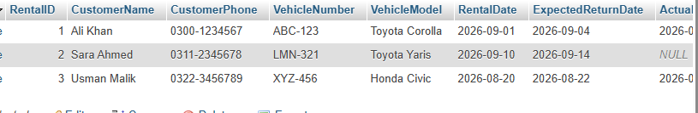

Trigger
A trigger is a database object that automatically performs an action when a specified database event occurs.
Two triggers were implemented in the system.
Vehicle Rented Trigger

It is executed after a new rental is inserted.
When a rental has an Active status, the trigger automatically changes the corresponding vehicle status to:
Rented
This prevents the vehicle status from incorrectly remaining Available after a rental is registered.

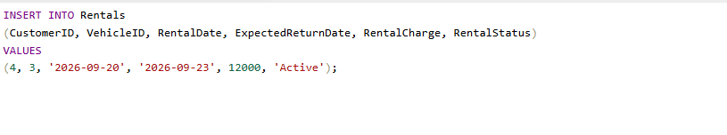

Trigger Testing
A new active rental was inserted for an available vehicle.
After the rental was inserted, the vehicle status was checked.
The vehicle status changed automatically to Rented.

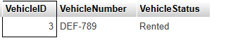

It is executed when a rental status is changed to Completed.
When the vehicle is returned, the trigger automatically changes the corresponding vehicle status to:
Available

Stored Procedure
A stored procedure named RegisterRental was created for registering a new rental.
The procedure accepts:
➢ Customer ID
➢ Vehicle ID
➢ Rental date
➢ Return date
The procedure then:
1. Checks the vehicle status.
2. Verifies that the vehicle is available.
3. Checks that the return date is not before the rental date.
4. Retrieves the vehicle's daily rental rate.
5. Calculates the rental period.
6. Calculates the total rental charge.
7. Inserts the new rental record.
8. Sets the rental status to Active.
This reduces the need to manually perform several operations when registering a rental.
Rental Charge Calculation
The rental charge is calculated using the vehicle's daily rate and the rental period.

The basic calculation is:
Rental Charge = Number of Rental Days × Daily Rate

Stored Procedure Validation
The procedure also checks whether the selected vehicle is available.
If the vehicle is already rented or unavailable, the procedure does not create a new rental.
It also checks that the return date is valid.
This helps prevent incorrect rental records.
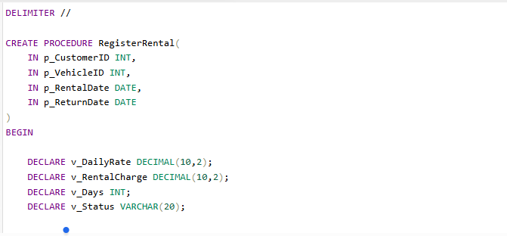

Check the New Rental
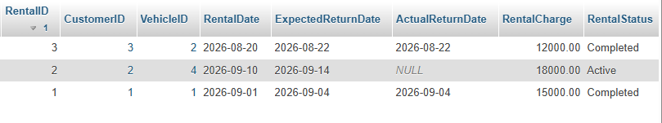

Check the vehicle
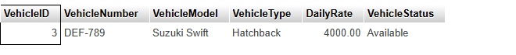

Optimization Analysis
Database optimization is important because a database may contain a large number of records.
Searching through a large Rentals table without suitable indexes can take more time.
In this system, rental records are frequently searched using:
➢ CustomerID
➢ VehicleID
➢ RentalStatus

Optimization Improvement
Indexes were created on commonly searched columns.
The improvements include indexes for:
• CustomerID in Rentals
• VehicleID in Rentals
• RentalStatus in Rentals
These indexes help the database locate relevant records more efficiently instead of scanning the entire table.
The optimization is particularly useful when the number of rental records becomes large.
CustomerID in Rentals

VehicleID in Rentals
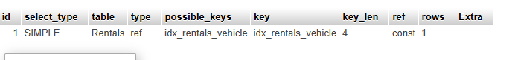

RentalStatus in Rentals

Testing Optimization
The EXPLAIN command can be used to examine how MySQL executes a query.
For example, a query that searches rental records by CustomerID can be examined using EXPLAIN.
The indexes can also be verified using the SHOW INDEX command.

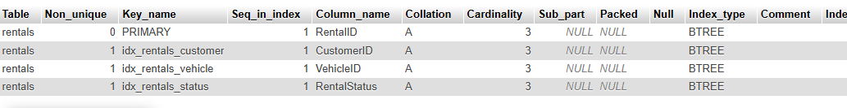

Testing and Verification
The completed database was tested to verify that the main functions work correctly.
The following features were tested:
Database
The database and tables were created successfully.
Sample Data
Customer, vehicle, rental, and payment records were inserted successfully.
Normalization
The original structure was converted from 1NF to 3NF.
JOIN Queries
All four required JOIN queries were executed successfully.
View
The RentalReport view successfully displayed consolidated rental information.
Trigger
The vehicle status automatically changed when a rental was created or completed.
Stored Procedure
The RegisterRental procedure successfully checked vehicle availability and calculated the rental charge.
Optimization
Indexes were added to commonly searched fields and verified using EXPLAIN and SHOW INDEX.

Conclusion
In this lab, a complete Car Rental Management System was designed using a relational database approach.
The database was normalized from 1NF to 3NF to reduce redundancy and avoid data anomalies. Different SQL JOIN operations were used to retrieve meaningful information from related table.

Overall Database designed:

